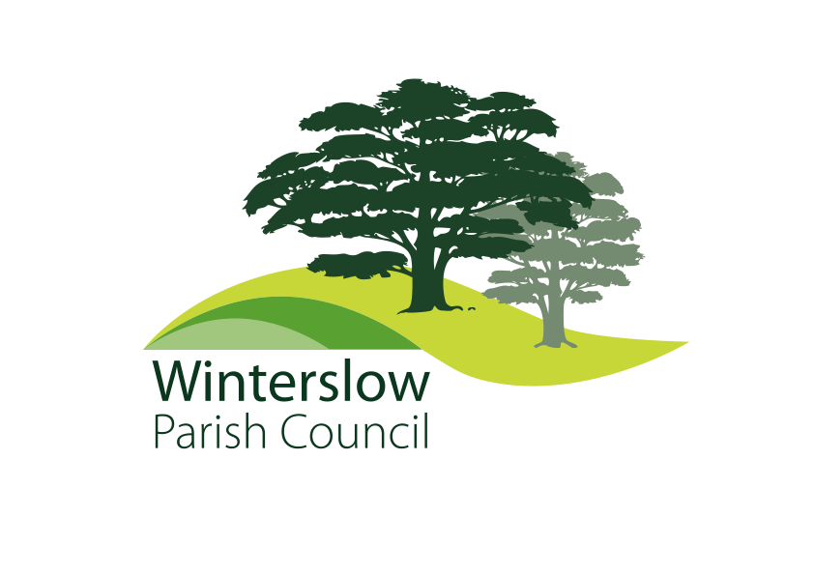

**Minutes of the Winterslow Parish Council Extraordinary meeting held at Barry’s Field Sports Pavilion, on Monday 16th September 2024 at 7.30 hrs.**

**Present: Cllr Taylor, Cllr Moody, Cllr Port, Cllr Warnes, Cllr Haynes and the Clerk, Jane Tier.**

**29 Members of the public attended the meeting.**

**Prior to the start of the meeting several members of the public spoke about agenda item 179.24, a letter from Primetower.**

**A summary of some of the issues that multiple residents raised concerns about are detailed below, with a brief response from Councillors.**

**Highways -concerns regarding access points to and from the site, narrow roads in the village, increased traffic congestion from any new potential site and increased traffic for building any new development.**

**Parish Councillors understand these concerns. Wiltshire Council Highways will be consulted on any new application.**

**Infrastructure – concerns that current infrastructure could not cope with increased traffic, use of village facilities will be adversely affected..**

**It was also suggested by a member of the public that Developers do not need to consider infrastructure when building new sites.**

**Developers – Why does the Parish Council engage with Developers?**

**The Parish Council has in place a Planning Negotiation Policy which enables negotiation with Developers on all matters appertaining to any potential development. The key principle is to negotiate changes to developers’ proposals that will benefit the community IF the development were to be approved by Wiltshire Council. Such negotiations do not prejudice in any way the Parish Council decisions when consulted on the application.**

**The National Planning Policy Framework (NPPF) states that** “39. Early engagement has significant potential to improve the efficiency and effectiveness of the planning application system for all parties. Good quality pre-application discussion enables better co-ordination between public and private resources and improved outcomes for the community.”

**Planning Application – When will a planning application be received.**

**The Parish Council does not have any indication of when an application is going to be submitted by Primetower.**

**See letter attached.**

**177.24 To receive apologies.**

*Apologies received from Cllr Bradley and Cllr Sheppard.*

**178.24 Declarations of Interest:**

(a) To receive **Declarations of Interest** in respect of matters contained in this agenda.

*None.*

(b).To consider any **Dispensation Requests** received by the Parish Clerk and not previously considered. *None.*

**179.24 Primetower**

To Resolve to acknowledge a letter from Primetower (see Appendix A), and to discuss and agree a plan for actions resulting from the letter. A Public Notice was issued by the Chairman. (see Appendix B)

*The Council discussed the appropriate way of responding to the Primetower letter and agreed to proceed with the requested engagement, subject to the Council first receiving more information from Primetower in relation to;*

*Their timescales for submitting a planning application*

*An indication of the key elements of their proposals.*

*Such information to be made public by the Council..*

*Winterslow Parish Council resolved therefore,to acknowledge the letter from Primetower and request more information as set out above..*

**180.24 To Resolve to agree a plan for Coopting new Parish Councillors at the October meeting.**

*Winterslow Parish Council resolved to agree a plan for Coopting new Parish Councillors at the October meeting***.** The plan includes an open meeting for those interested, receipt of a written personal statements, interaction with all Councillors at the Oct meeting. Applications close on 25th Sept.

**181.24 To confirm the date of the next full council meeting.**

*The next full meeting of Winterslow Parish Council is on 7th October.*

**182.24 To close the meeting.**

*The meeting closed at 9.10pm.*

**Appendix A**

PRlMETOWER

Winterslow Parish Council by email only c/o Jane Tier

Winterslow Parish Clerk

40 Firs Road

Firsdown

Salisbury

SP5 ISL

1 0 September 2024

Dear Councillors,

# Land off Middleton Road Middle Winterslow

It has been some time since our last communications, and as always, we are keen to engage with the Parish Council at an early stage to establish the current position and circumstances within and around the village, including what WPC expectations are for Winterslow going forward.

To be clear, we are not presenting a development scheme nor a planning application but looking to establish what the PC expectations would be if such an application were to be made at a future date. The NPPF is clear that the best possible economic, social, and environmental outcomes should always be sought, it is this we are following.

By way of example, we have recently become aware of the proposals to create an integrated cycleway network within the village better linking key destinations. Concerns are noted from the presentation regarding potential user conflicts on Middleton Road directly adjoining the site. As you may recall, previous proposals from us incorporated a network of routes that would directly overcome these issues. We also suspect you will wish to discuss school pupil numbers, and other issues that do and/or will affect village life at some point. This is a fact-finding exercise on our part and we believe you are uniquely placed to draw together the wants and needs of the many interested parties.

As a general observation based on past experiences, we appreciate that there will always be local interest in any development proposals for this land and we think it would be helpful for both parties to pull together/understand what it is WPC seek going forward. This dialogue can be commenced via email outlining your position and views, or we are more than happy to meet up and discuss the site if that is a more suitable way to move forward. Experience suggests that a working committee is a more effective method.

We also appreciate that WPC will want to involve the wider village, however at this initial, early stage we do first need an agenda from WPC to work from and we foresee a wider audience some way down the line as proposals evolve.

I look forward to hearing from you.

Primetower Properties Ltd I Park Place 6 North Road Poole Dorset BH 1 4 OLY

t.01202 71557/ f. 0/202 118971 www.primetower.com

Directors: R.J. Harding,J.A.Yeoman, M.P.Jones FCCA. Registered office: as above. Registered number: 2938378

**Appendix B**

**PRIMETOWER PARISH COUNCIL NOTICE 11.9.24**

The Parish Council has received a letter** from Primetower proposing ‘engagement’ with the Council to discuss what the community would currently seek if there was a new development proposal for the land at Middleton Road.

The letter will be discussed by Councillors at an Extraordinary General Metting of the Council at 7.30 on Monday 16th September at Barry’s Fields.

The Council has a formal policy** governing any such ‘engagement’ with a developer.

**PLEASE NOTE: There is no Planning Application for the Council and parishioners to comment on.** Our current understanding is that, if there is to be an application, it will not be for many months. We will keep you informed.

There is, however, an opportunity to make the developer aware of any changes in the village since the last application that should be considered in any future proposal for the site. We would welcome input from parishioners, organisations, public and private services.

At the time of previous proposals, the Council was able to negotiate changes to the planning application to provide benefits to the community to be delivered IF the application had been approved.

Such benefits included:

* improved separation from Village Hall
* changes to housing numbers, design, types, and layout
  + more Affordable Homes
  + homes designed for the elderly
  + more ‘starter’ homes
* improved car parking
* new footpaths/cycle tracks
* new playground/equipment
* improved protection for Brown’s Copse
* contributions to Village Hall facilities

Mike Taylor

Chair WPC

** Document on the PC website